Chapter 10, Problem 95.

Fig. 10.136 shows a Hartley oscillator. Show that the frequency of oscillation is

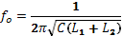
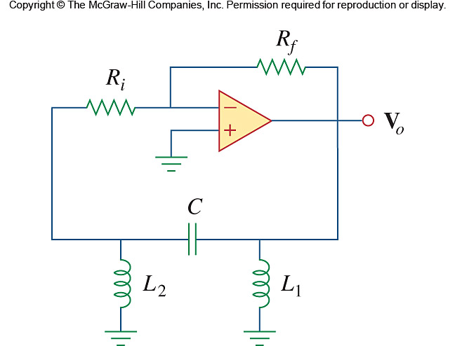

Figure 10.136
For Prob. 10.95.

